
T5 Q1Koneru Lakshmaiah Education Foundation
(Deemed to be University estd. u/s. 3 of the UGC Act, 1956)
Off-Campus: Bachupally-Gandimaisamma Road, Bowrampet, Hyderabad, Telangana - 500 043. Phone No: 7815926816, www.klh.edu.in

STUDENT CASE STUDY EXECUTION REPORT
Department | FED
Subject | DSA-2
Academic Year | 1-111 Semester | 2025-26
Faculty Name | Mohd. Razia Alangir Banu
Student Name | M. Shravya
Roll Number | 2520030588
Branch | CSE
Course Outcome | CO 3
Case Study Topic: Mentor Collaboration Network using BFS and DFS
Work Done Summary:
In this case study, we implemented a graph-based Mentor Collaboration Network for the Skill Bridge – Online Skill Development & Certification Platform. Mentors were represented as graph vertices, while collaboration relationships between mentors were represented as edges. Breadth First Search (BFS) and Depth First Search (DFS) algorithms were used to discover connected expert groups and analyze mentor collaboration patterns.

Implementation Details:
1 Represented mentors as graph vertices.
2 Established mentor collaboration links using graph edges.
3 Implemented BFS traversal to discover connected mentor groups level by level.
4 Implemented DFS traversal to explore complete collaboration networks.
5 Identified connected components representing expert communities.
6 Compared BFS and DFS traversal results for mentor network analysis.

Result: Screenshots / Output

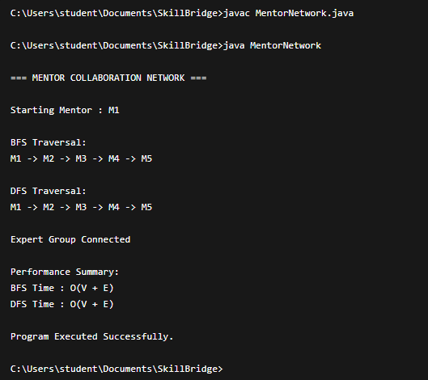

Time Complexity:
Operation | Complexity
BFS Traversal | O(V + E)
DFS Traversal | O(V + E)
Graph Creation | O(V + E)
Connected Component Detection | O(V + E)
Where:
- V = Number of mentors (vertices)
- E = Number of collaborations (edges)

Result

The graph-based Mentor Collaboration Network successfully identified connected expert groups using BFS and DFS traversal algorithms. The system efficiently analyzed mentor relationships and collaboration structures, making it suitable for large-scale professional networking and mentorship platforms.

GitHub Link:
Student Signature Faculty Signature

